Making the Document Header Posting Account Invisible

This is from PODocumentHeader. When IsPosted is False, line 0 isn’t written to gl_cost_transactions.

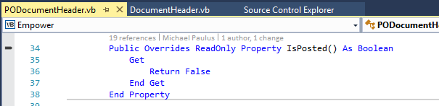

This is from Document Header. When IsPosted is False the Posting Account is neither visible in the GL group box nor validated.

